

**Course Name:-**Open Source Development For Google applications

**Course Code:-EXC1081**

**Name of the Project:-**SpaceFinder

**Name:-**Abhinav Visen

**Registration Number:**-14BCB0070

**Abstract**

As we know that our International Space System also known as the ISS continuously orbits around the earth gathering the information regarding the planet and all other planet cosmos.So its position is not static ,the project deals with locating the current position of the ISS in the real time.

**Introduction**

The Project deals with plotting the current location of the ISS in the real time.The entire source code is written in python and Turtle a well renowned python library has been used for the Graphics User Interface for plotting the ISS position in the 2D map.The Application Programming Interface(API) provides with the necessary real time data required for the plotting the position.Their are two API’s that has been used in this project.One API gives the number of people and the current crew stationed at the ISS, while the second API gives the coordinates of latitudes and longitudes of the ISS.

**Methodology**

A brief methodology:-

* Retrieving the Data.
* Manipulating the Data.
* Displaying the Data.

Now, let’s check the Detailed methodology step by step:-

* Importing important python modules required for the Project (Turtle,urllib,json).
* Storing the web page in the variable.
* Requesting to open the url and reading the data simultaneaously converting them into the dictionary as the data received from the API will be in JSON format(Javascript Object Notation- It is nothing but a form of representing the data).
* Same process is repeated to for the Second API for storing the latitude and longitude in the variable and displaying the relevant locations.
* Now loading a GUI screen and resizing it according to the proper width in order to for pointing the location.
* Loading the pointer for pointing the location
* Passing the variables in float(Remember the resulted data is still in string format so we need to convert it into float for exact location.

**Result**

Result of the First API CALL:-

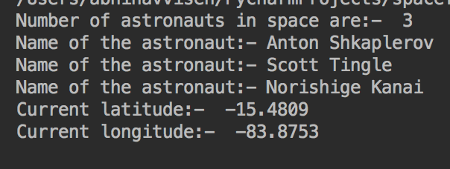

Result of the second API CALL:-

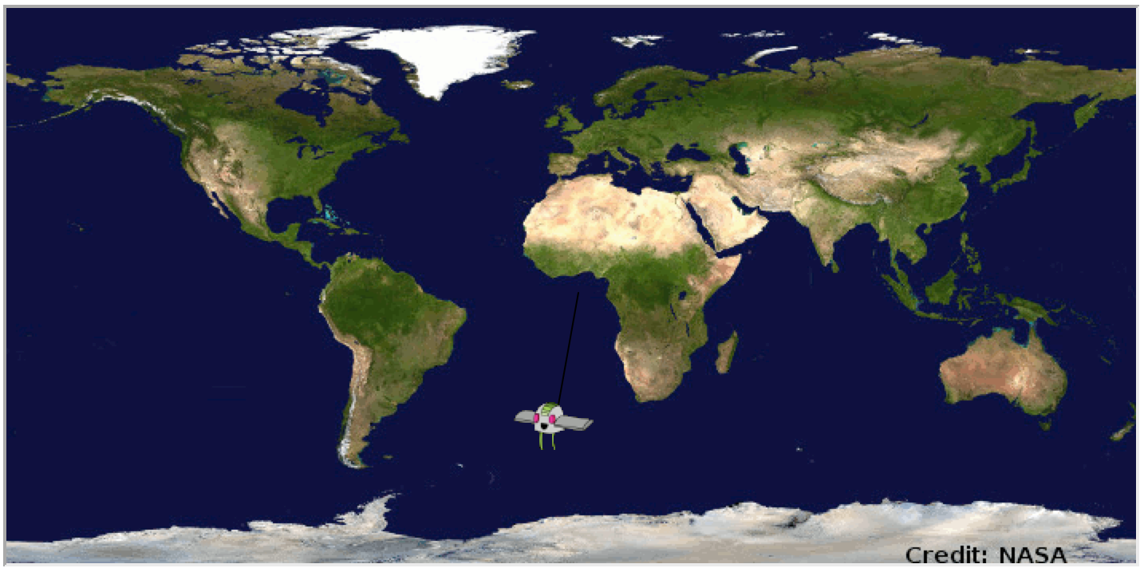

The difficult part was the end part of the program as their was a problem with the turtle library and could not display the GUI.So with assisted help with Stackoverflow the program was completed with the help of simple function which initiates the GUI.(done()).

**Conclusion**

The Project was successfully implemented in python.

**References**

* <https://www.google.co.in/search?q=WORLD+MAP+2D+PLOTIING+ISS+image&oq=WORLD+MAP+2D+PLOTIING+ISS+image&aqs=chrome..69i57.12125j1j1&sourceid=chrome&ie=UTF-8>
* https://stackoverflow.com/